**HO CHI MINH CITY   
UNIVERSITY OF TECHNOLOGY AND EDUCATION**

**FACULTY OF HIGH QUALITY TRANING**

**🙡🙟🕮🙝🙣**

**INTERNET OF THINGS FOUNDATIONS AND APPLICATIONS**

**SIMULATION AND EXECUTION ON THE HARDWARE WITH AMQP PROTOCOL.**

|  |
| --- |
|  |

**Lecturer: Ph.D Võ Minh Huân**

**Class: ITFA336064E_21_3_01CLC**

***Ho Chi Minh City, July 2022***

**LIST OF GROUPS INVOLVED IN WRITING REPORT**

**SEMESTER III, ACADEMIC YEAR: 2021.-2022**

**Group 1. Wednesday - Thursday Lessons 07-15**

**Topic: Simulation and execution on the hardware with AMQP protocol.**

|  |  |  |
| --- | --- | --- |
| **No.** | **Full Name** | **Process** |
| **1** | **Nguyễn Tiến Đạt** | **100%** |
| **2** | **Trần Nguyễn Anh Khoa** | **100%** |

**Comments:**

**…………………………………………………………………………………………………………………………………………………………………………………………………………………………………………………………………………………………………………………………………………………………………………………………………………………………………………………………………………………………………………………………………………………………………………………………………………………………………………………………………………………………………………………………………………………………………………………………………………………………………………………………………………………………………………………………………………………………………………………………………………………………………………………………………………………………………………………………………………………………………………………………………………………………………………**

***Ho Chi Minh City, … July 2022***

**Grading instructors**

**Table of Contents**

**Overview Topic 4**

**A. Advanced Message Queuing Protocol 5**

**1.1 Introduction to Advanced Message Queuing Protocol. 5**

**1.2 AMQP 1.0 technical features 6**

**1.3 Introduction to RabbitMQ model 7**

**1.4 Compent of AMQP 9**

**1.5 What are AMQP and MQTT 14**

**1.6 Different between AMQP – MQTT 15**

**Security 16**

**Easy to implementation 17**

**Extensibility 17**

**Rebiability 18**

**Messaging Pattern 19**

**The benefits and limitations of AMQP – MQTT 20**

**B. Product 21**

**Conclusion 29**

**Rerestriction 29**

**Development orientation 29**

**REFERENCES 30**

# Overview Topic

The software industry is a fast-moving business, new programming languages and application frameworks are introduced at a sometimes bewildering pace. Similarly, the requirements of IT systems evolve over time and developers want to take advantage of the latest platform features. However, sometimes the selected messaging vendor doesn't support these platforms. If messaging protocols are proprietary, it's not possible for others to provide libraries for these new platforms. Therefore, you must use approaches such as building gateways or bridges that enable you to continue to use the messaging product. The problem here is a huge amount of human-made information. How can we control this, and how can we process it faster and be scaled more?

The development of the Advanced Message Queuing Protocol (AMQP) was motivated by these issues. It originated at JP Morgan Chase, which, like most financial services firms, is a heavy user of message-oriented middleware. The goal was simple: to create an open-standard messaging protocol that made it possible to build message-based applications using components built using different languages, frameworks, and operating systems, all using best-of-breed components from a range of suppliers.

On this topic, we will create simulation and execution on the hardware with the AMQP. We will deploy this simulator on the Rasberry Pi 4 and show you how it works.

1. **Advanced Message Queuing Protocol**

**1.1 Introduction to Advanced Message Queuing Protocol.**

Advanced Message Queuing Protocol is a framing and transfer protocol. Framing means that it provides structure for binary data streams that flow in either direction of a network connection. The structure provides delineation for distinct blocks of data, called frames, to be exchanged between the connected parties. The transfer capabilities make sure that both communicating parties can establish a shared understanding about when frames shall be transferred, and when transfers shall be considered complete.

The protocol can be used for symmetric peer-to-peer communication, for interaction with message brokers that support queues and publish/subscribe entities. It can also be used for interaction with messaging infrastructure where the interaction patterns are different from regular queues. The client picks an offset into the available data stream and is then served all events from that offset to the latest available.

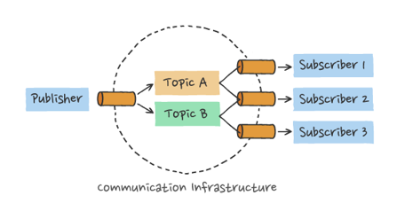

**Figure 1. Publisher/Subscriber model.**

The AMQP 1.0 protocol is designed to be extensible, enabling further specifications to enhance its capabilities. The three extension specifications discussed in this document illustrate this. For communication over existing HTTPS/WebSockets infrastructure, configuring the native AMQP TCP ports may be difficult. A binding specification defines how to layer AMQP over WebSockets. For interacting with the messaging infrastructure in a request/response fashion for management purposes or to provide advanced functionality, the AMQP management specification defines the required basic interaction primitives. For federated authorization model integration, the AMQP claims-based-security specification defines how to associate and renew authorization tokens associated with links.

## 1.2 AMQP 1.0 technical features

AMQP 1.0 is an efficient, reliable, wire-level messaging protocol that you can use to build robust, cross-platform, messaging applications. The protocol has a simple goal: to define the mechanics of the secure, reliable, and efficient transfer of messages between two parties. The messages themselves are encoded using a portable data representation that enables heterogeneous senders and receivers to exchange structured business messages at full fidelity. Here's a summary of the most important features:

* **Efficient:** AMQP 1.0 is a connection-oriented protocol that uses a binary encoding for the protocol instructions and the business messages transferred over it. It incorporates sophisticated flow-control schemes to maximize the utilization of the network and the connected components. That said, the protocol was designed to strike a balance between efficiency, flexibility, and interoperability.
* **Reliable:** The AMQP 1.0 protocol allows messages to be exchanged with a range of reliability guarantees, from fire-and-forget to reliable, exactly once acknowledged delivery.
* **Flexible:** AMQP 1.0 is a flexible protocol that can be used to support different topologies. The same protocol can be used for client-to-client, client-to-broker, and broker-to-broker communications.
* **Broker-model independent:** The AMQP 1.0 specification doesn't make any requirements on the messaging model used by a broker. This means that it's possible to easily add AMQP 1.0 support to existing messaging brokers.

## 1.3 Introduction to RabbitMQ model

In general, a broker is a person who facilitates trades between a buyer and a seller. An example could be a real estate agent or a stockbroker.

Similarly, if we want to trade messages between two distributed software components, we need a mediator. This mediator is known as the message broker. It receives incoming messages from a sender and sends them to a recipient. This way the sender and receiver can be totally isolated.

Another analogy for a message broker can be a Post Office. Let’s take a scenario where you are going to send a letter to your cousin living in another city. Then as per this analogy, you are a producer, your cousin is a consumer, and the post office is a message broker.

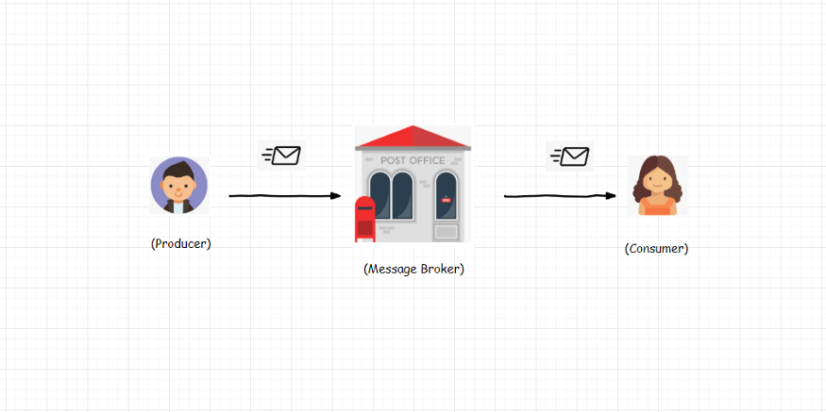

**Figure 2: Analogy for message broker**

Now we know that the purpose of a message broker is to route messages from a producer to a consumer. Let’s examine one such message broker — RabbitMQ. It’s one of the most extensively used message brokers these days.

The way RabbitMQ routes messages depends upon the messaging protocol it implements. RabbitMQ supports multiple messaging protocols. However, the one we are interested in is AMQP. It is an acronym for Advanced Message Queuing Protocol.

The conceptual model of AMQP is quite simple and straightforward. It has three entities: **Queue – Binding – Exchanges.**

When a publisher pushes a message to RabbitMQ, it first arrives at an exchange. The exchange then distributes copies of these messages to variously connected queues. Finally, consumers receive these messages.

Consider a message as a piece of data. It is necessarily a package with a payload and some meta-data. The payload contains full data whereas meta-data are properties used by RabbitMQ.

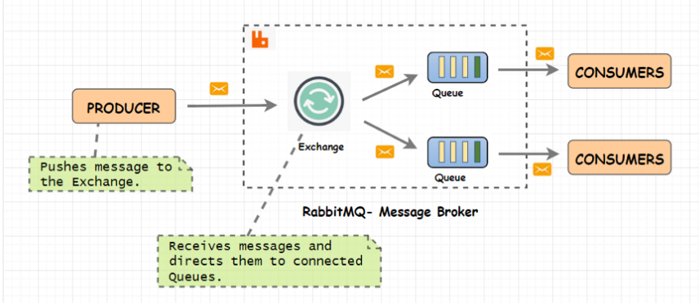

**Figure 3: AMQP Model**

AMQP is a programmable protocol. Programmers have the liberty to use libraries to configure entities (exchange, binding, and queue) as per their own needs. A RabbitMQ admin has no role in setting up these entities. There are plenty of libraries available to work with RabbitMQ. You can choose from [Nodejs](http://www.squaremobius.net/amqp.node/), [Python](https://pypi.org/project/pika/), .[Net](https://github.com/rabbitmq/rabbitmq-dotnet-client), [Java](https://github.com/rabbitmq/rabbitmq-java-client/), and many more.

* 1. **Compent of AMQP**

**1.4.1 Queues**

These queues are somehow similar to the queues from our data structure classes. RabbitMQ queues also follow FIFO — First-In-First-Out methodology. A queue is a place where RabbitMQ stores messages/data.

Programmers can configure queues through available programming libraries. You can make a queue durable (with the Durability property) to safeguard your data in case the broker crashes. You can also provide a name (with the Name property) to a queue. Other than Name and Durability, a queue has a few other properties like auto-delete, exclusive, and arguments.

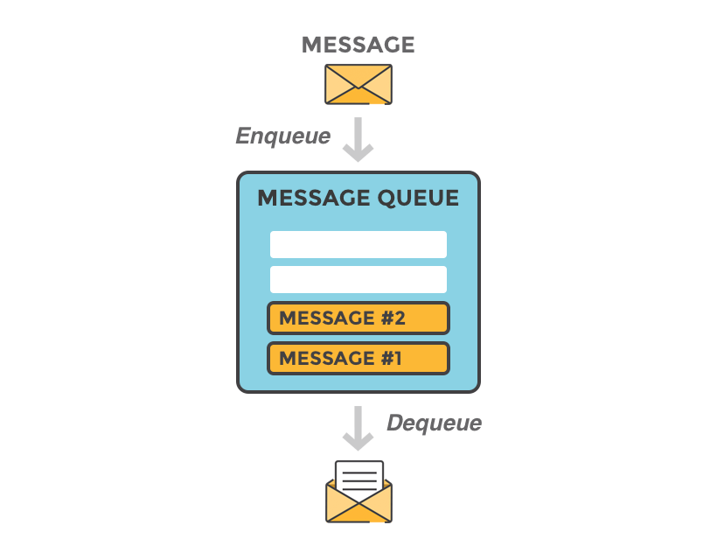

**Figure 4: Message Queue**

**1.4.2 Binding**

Bindings are the rules that a queue defines while establishing a connection with an exchange. You can have a queue connected to multiple exchanges. Every queue is also connected to a default exchange. An exchange will use these bindings to route messages to queues.

**1.4.3 Exchanges and their types**

An Exchange is a gateway to RabbitMQ for your messages. The distance the message has to travel inside RabbitMQ depends on the type of exchange. Primarily there are four types: **Direct – Fanout – Topic – Header**.

**Direct**

The name explains it all! - A direct exchange delivers a message directly to the queues that satisfy the below condition:

**Routing key == Binding key**

A routing key is an attribute of the message. On the other hand, a binding key is something you specify while creating a binding between a queue and an exchange.

A message originates from a producer (green circle) with a **routing key - img.resize.** Once it reaches the exchange (Orange circle), the exchange will try to find all queues with **binding key - img.resize**. In case of a match, the message is pushed to all matched queues (resize in our case). If there is no match found, the message can be sent back to the producer or can even be discarded.



**Figure 5: Direct exchange**[**Visualizer**](https://jmcle.github.io/rabbitmq-visualizer/)

Once the message reaches the desired queue (resize in our case), they are distributed in round-robin fashion to all the connected consumers (resizer.1/resizer.2 in our case).

By distributing messages in a round-robin fashion, RabbitMQ makes sure that the messages are load balanced.

You must have noticed that the queue named **crop**is not receiving any messages. Because the routing key in this example is img.resize. To send messages to this queue, we need to send messages with a routing key that would match the binding key (say img.crop for instance).

**Fanout**

A Fanout exchange ignores routing keys and distributes a message to all the connected queues. No wonder it is called Fanout (blowing messages to all connected queues ). One of the use cases for this type of exchange is message broadcast.



**Figure 6: Fanout exchange**[**Visualizer**](https://jmcle.github.io/rabbitmq-visualizer/)

**Topic**

A topic exchange routes a message by matching routing key with a pattern in the binding key.

**Routing key == Pattern in binding key.**

RabbitMQ uses two wild card characters for pattern **matching * and #.** Use a **\*** to match 1 word and a **#** to match 0 or more words.

Figure 5 is a visual depiction of a topic exchange. Messages **with routing key - logs.error**will **match patterns - logs.error and logs.*.** Hence these messages will end up in the queues - only error and all logs.

Whereas for the producer at the bottom-left, messages with **routing key - logs.success** will match patterns of **binding key #success and logs.\*** . Hence these messages will end up in the queues — all logs and only success.

**Figure 7: Topic exchange**[**Visualizer**](https://jmcle.github.io/rabbitmq-visualizer/)

This type of exchange has a vast range of use cases. It can be used in the publish-subscribe pattern, distributing relevant data to desiring workers processes and many more.

**Header**

A header is a particular type of exchange that routes messages based on keys present in the message header. It overlooks routing key attribute of the message.

When creating bindings for a header exchange, it is possible to bind a queue to match more than one header. In such a case, RabbitMQ should know from the producer if it should match all or any of these keys.

A producer/application can do this by providing an extra flag called ‘x-match’. ‘x-match’ can have any or all values. The first one mandates that only one value should match while the latter mandates that all must match.

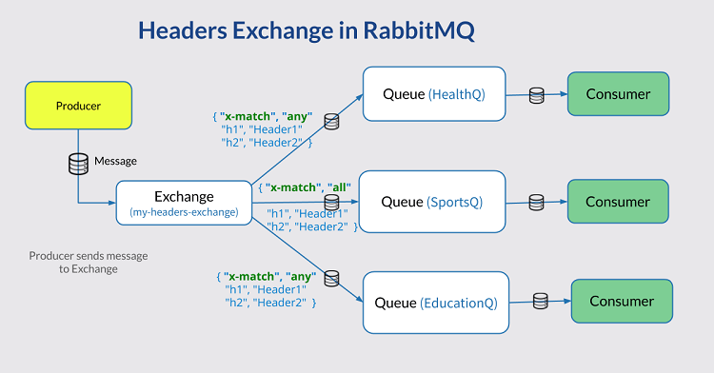

**Figure 8: Header Exchange Description**

**Message Acknowledgement**

Once a message reaches its destination, the broker should delete the message from the queue. It is necessary because a queue overflow can occur if it keeps accumulating messages.

Before deleting any message, the broker must have a delivery acknowledgment. There are two possible ways to acknowledge message delivery.

* Automatic acknowledgment: Once a consumer receives the message
* Explicit acknowledgment: When a consumer sends back an acknowledgment

In most cases, explicit acknowledgment is used as it makes sure that the consumer has consumed the message without any failover.

## What are AMQP and MQTT

AMQP (Advanced Message Queuing Protocol) is a binary messaging protocol designed to effectively support a wide range of messaging applications and communication patterns. Its use of a streamed binary messaging system allows for the interoperability of clients from different vendors. This makes AMQP shine in multi-client environments.

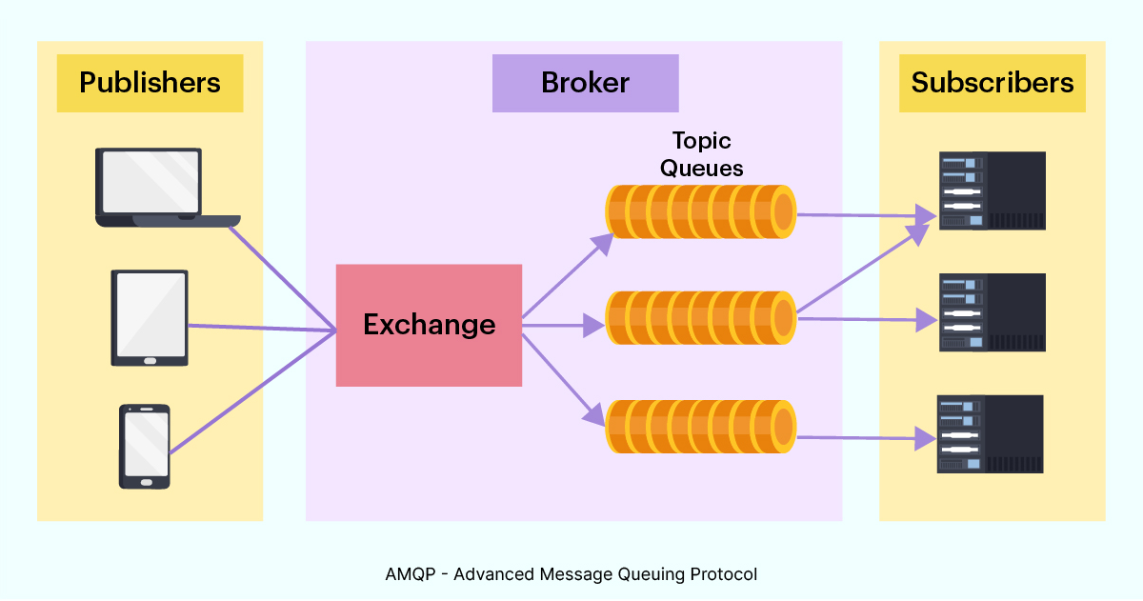

MQTT (MQ Telemetry Transport) is a lightweight messaging protocol designed for high-latency, low-bandwidth, and unreliable networks. It consumes very little power on the device it’s running on. Due to its low overhead, MQTT is most often used in an embedded environment for machine-to-machine communication. Its use is prevalent in industries such as automotive, manufacturing, telecommunications, and smart homes.

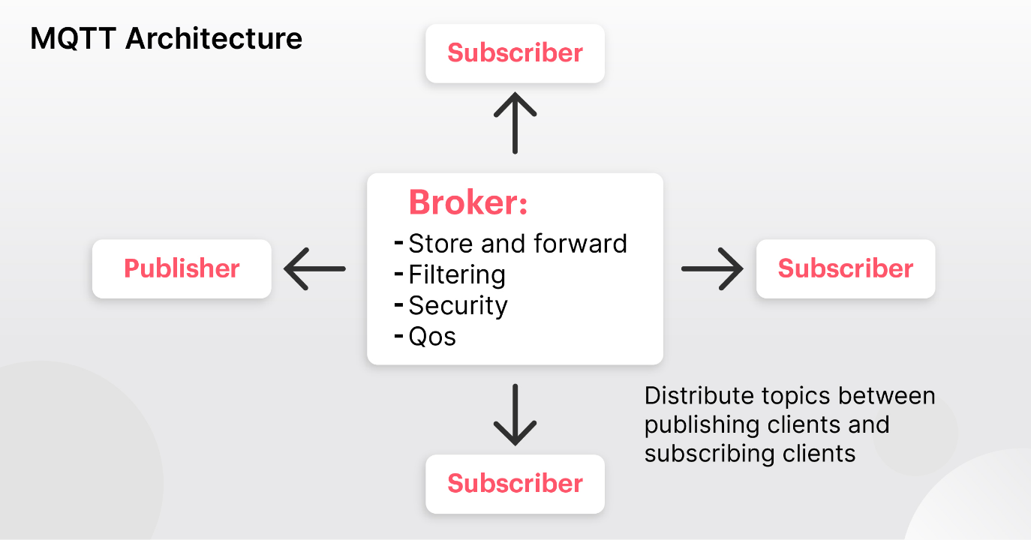

## 1.6 Different between AMQP – MQTT

**Big difference**

AMQP was born in the financial industry. The finance community wanted a way to avoid dealing with the licensing headaches of proprietary systems. So, they created AMQP to provide an open-source method of communicating the vast amount of market data to and from financial systems. Development was customer-driven.

MQTT, on the other hand, was born in the technology industry. It was created by IBM and its partners to allow the MQSeries of products to work efficiently on smaller devices. Unlike AMQP, MQTT’s development was vendor-driven.

**Comparing AMQP – MQTT**

Both protocols play the same role in an application—allowing programs to send and receive asynchronous messages no matter what operating systems, hardware, and programming languages are used.

Because they fulfill the same function, AMQP and MQTT are most often used independent of each other. However, if you have a complex system with many different types of devices and connections, both protocols can be effectively leveraged to work together by playing on their individual strengths.

As mentioned above, despite both performing the same function, AMQP and MQTT are designed for different purposes. MQTT is ideal for a large number of size-constrained devices to send small messages over a low-bandwidth network. AMQP, on the other hand, is designed to be able to allow for the full suite of messaging patterns and handle any type of scenario.

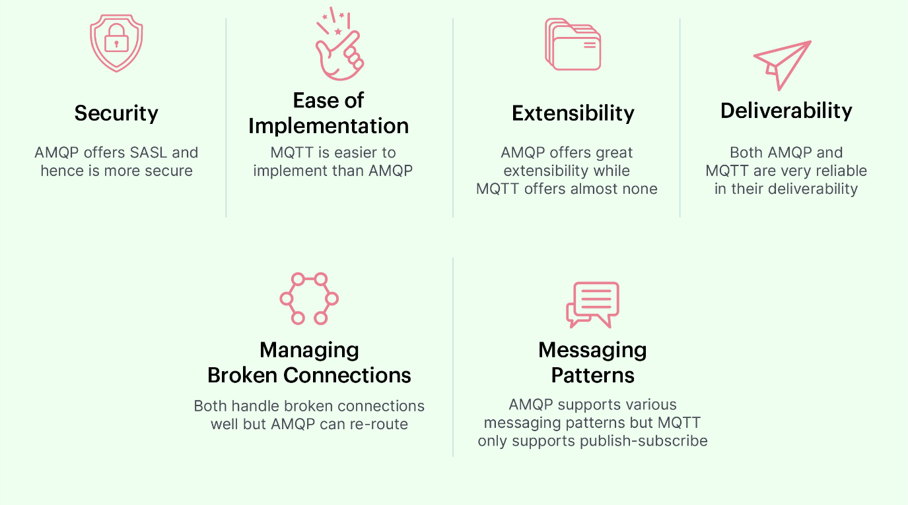

### **Security**

Security is almost always a top concern when choosing a messaging protocol. While it’s a moving target and nothing is 100% secure, integrated security features are a great plus to have.

Regarding connection security, both AMQP and MQTT integrate with TLS (Transport Layer Security), which encrypts the data on transfer. In addition to that, AMQP offers SASL (Simple Authentication Security Layer), which allows for a secure authentication handshake between client and server. MQTT doesn’t offer SASL out of the box, but it can be added manually.

When it comes to user security, MQTT requires short usernames and passwords. Unfortunately, these don’t provide enough security for the modern world of intensive brute-force attacks. And, since this policy is built into the protocol, you'll have to cross your fingers and hope they eventually address the security weakness via a new protocol version. AMQP, on the other hand, uses SASL to allow you to choose whatever type of security measures you find necessary.

**In matters of security, AMQP has the upper hand.**

### **Easy to implementation**

As a smaller, simpler protocol, MQTT is easier to implement than AMQP. At least, it would be easier to implement—if it weren't for open-source libraries.

Both protocols are open-source, which has resulted in the creation of several open-source implementation libraries for each protocol. No matter which operating system or language you choose for your chat app, you’ll be able to find an open-source library that makes implementing either protocol a breeze.

The existence of these open-source implementation libraries makes comparing ease of implementation a wash.

### **Extensibility**

AMQP is a layered protocol. This means that a change in one layer is isolated from the rest, which makes extending the protocol easy. This also means that any future extensions are automatically backward-compatible. MQTT is not layered. So, any changes in the protocol require a completely new version.

**AMQP is therefore the winner in regards to extensibility.**

### **Rebiability**

When it comes to messaging applications, there are two critical components of reliability: deliverability and the handling of broken connections. Let's start with deliverability.

Your end users need to be able to trust that their messages are being delivered. But that’s not all. They also have to be confident that their messages are received just once, as duplicate messages can overload the client, cause loss of information, and create false data. And finally, they want to know that their messages are being received in the right order.

Both AMQP and MQTT claim to be very reliable in their deliverability. They both offer three QoS (Quality of Service) levels. (The more QoS levels, the more reliable it is. The three QoS levels are:

* **At most once (0):** The lowest QoS level, here the recipient does not acknowledge receiving the message and the message is not stored and resent by the sender. There is no guarantee of delivery.
* **At least once (1):** Level 1, the sender stores the message until it receives a ping from the receiver acknowledging delivery. Level 1 guarantees that the message is delivered at least once. But, on level 1 it is possible that a message gets sent and delivered multiple times. This level doesn’t guarantee the correct ordering of messages.
* **Exactly once (2):** The highest QoS that MQTT and AMQP offer, this is the safest QoS level. It is also the slowest QoS level. It guarantees that the recipient will receive a message just once and that they'll be in the correct order. This is achieved with a four-part handshake between sender and recipient.

Now, on to broken connections. When a connection between client and server is broken on an MQTT protocol, a “Last Will” message is sent to the server. This allows the server to alert other clients that a connection was lost. On an AMQP protocol, you can specify “forwarding addresses” where messages will be sent if a connection is interrupted or unexpectedly dies. Both protocols handle broken connections, but AMQP does it more gracefully.

**AMQP is slightly more reliable than MQTT when it comes to broken connections but they are on equal footing when it comes to deliverability.**

### **Messaging Pattern**

MQTT only supports one type of messaging pattern: publish-subscribe messaging to topics. An MQTT client can either publish or subscribe to a “message topic”. When the client publishes a message to a broker it contains a message topic. When the broker receives the published messages, it uses the message topic to determine which other clients are subscribed to that specific topic. It then routes the message to those clients.

AMQP is much more flexible. It allows almost any form of messaging pattern, including classic message queues, publish-subscribe, round robin, and store-and-forward. It also allows numerous combinations of these patterns. And, AMQP uses message meta-data to support message grouping.

**AMQP is the clear winner when it comes to the implementation of different types of messaging patterns.**

### **The benefits and limitations of AMQP – MQTT**

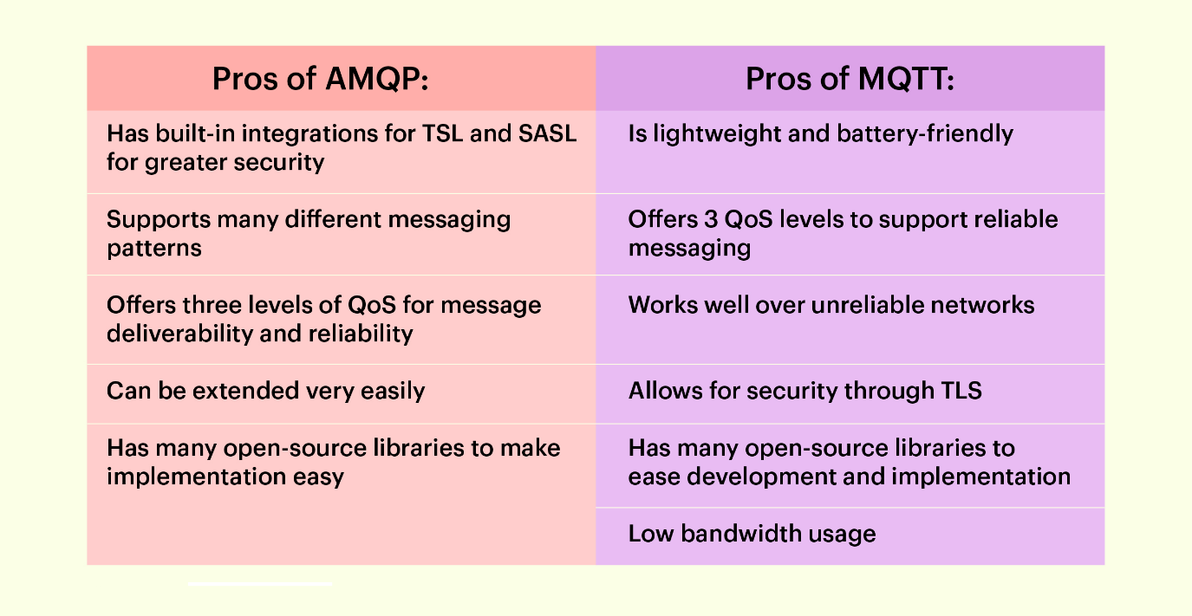

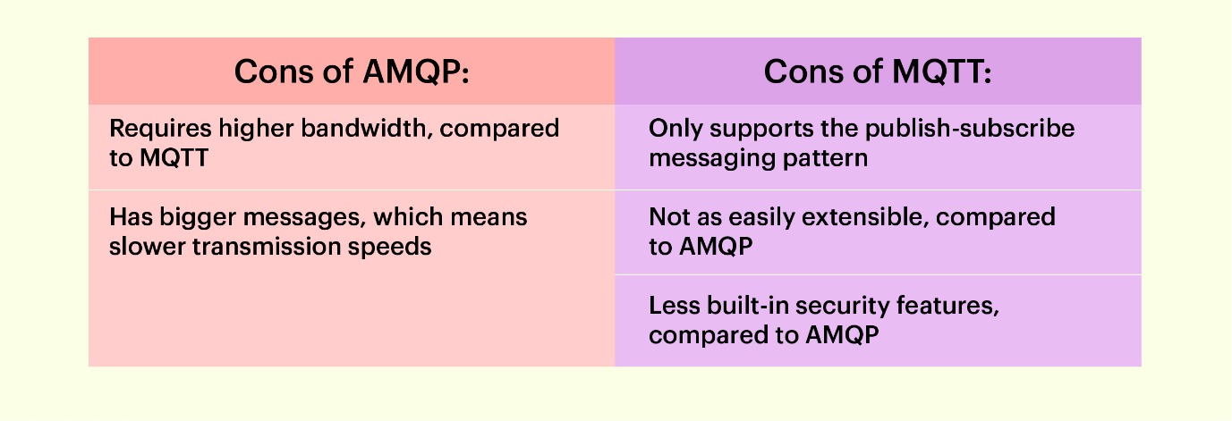

# B. Product

At first step, we run files ***taxi4_binhthanh.py, taxi4_d1.py, taxi4_thuduc.py, taxi7_binhthanh.py, taxi7_d1.py, taxi7_thuduc.py***to create queues on <http://localhost:15672/> ( Make sure start RabbitMQ ), such as:

**DISTRICT_BINH_THANH_4seat, DISTRICT_1_4seat, DISTRICT_THU_DUC_4seat, DISTRICT_BINH_THANH_7seat, DISTRICT_1_7seat, DISTRICT_THU_DUC_7seat.**

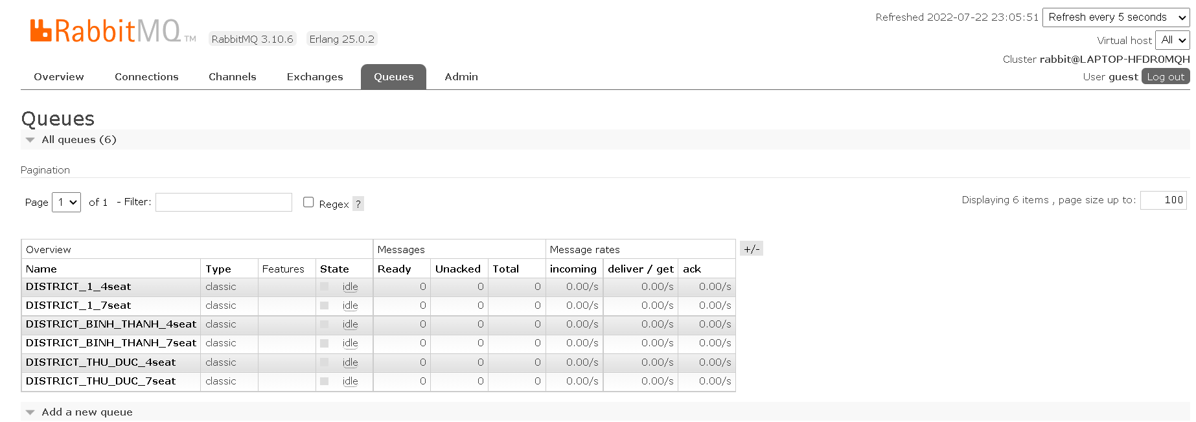

Next, we move to **Connections.** There are 6 connections corresponding to 6 python files are running.

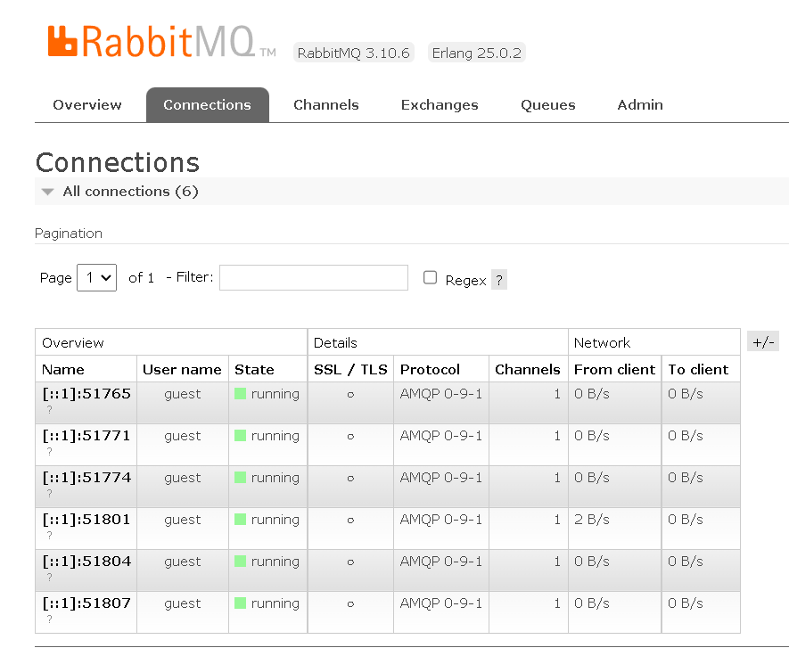

In Terminal, after we run python files:

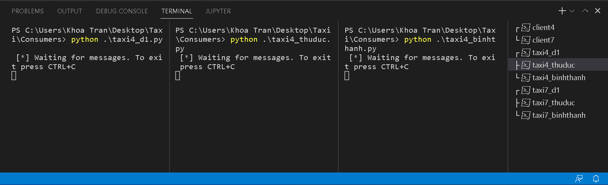

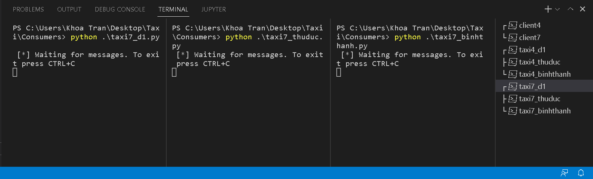

Second, we run files ***client4.py, client7.py***to declare topic exchanges **‘seatexchange’, ‘taxi4-place_exchange’ and ‘taxi7-place_exchange’** on http://localhost:15672/

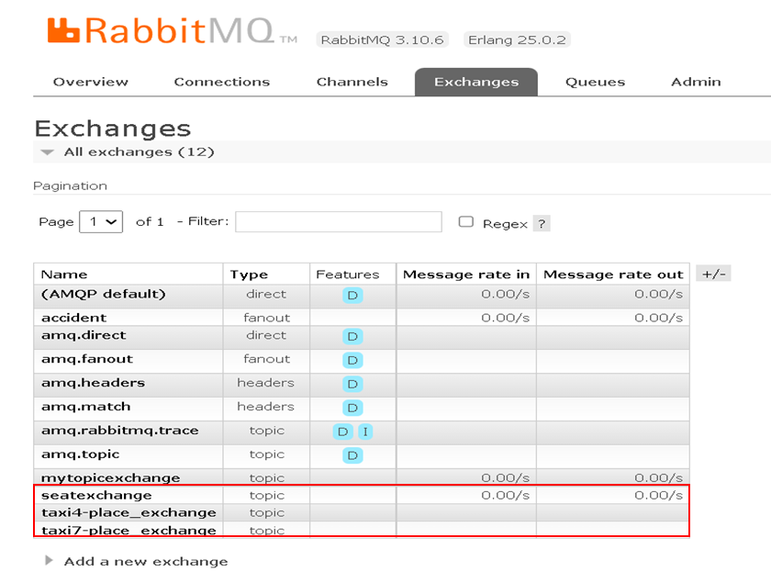

Inside **‘seatexchange’**, we can see in **Bindings**. There are 2 exchanges will be received message from **‘seatexchange’** with the routing keys which we declared before.

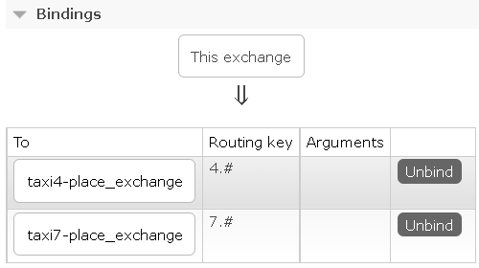

Inside **‘taxi4-place_exchange’** and **‘****taxi7-place_exchange’**

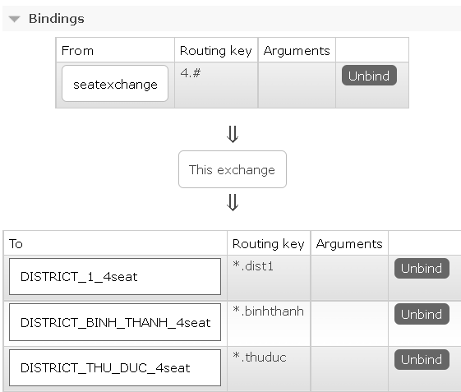

taxi4-place_exchange

This exchange will receive message from **‘seatexchange’** and send it to 3 different queues with 3 relevant routing keys.

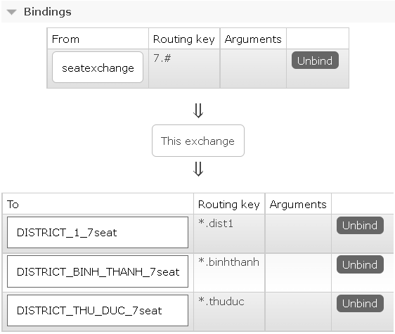

taxi7-place_exchange

This exchange will also receive message from **‘seatexchange’** and send it to 3 different queues with 3 relevant routing keys.

In Terminal, after we run python files:

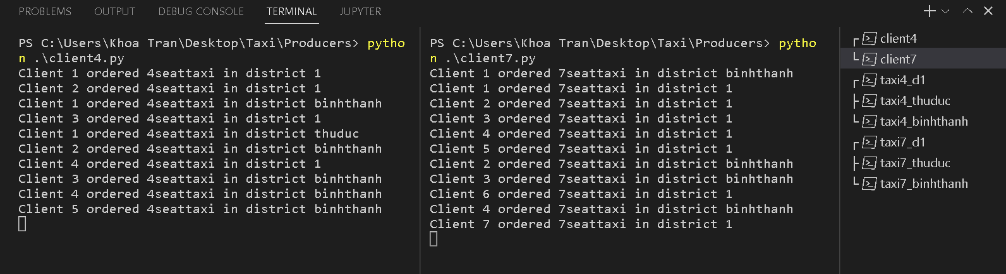

At the same time, all consumers receive the message, but for each, it will take an unpredictable period to process.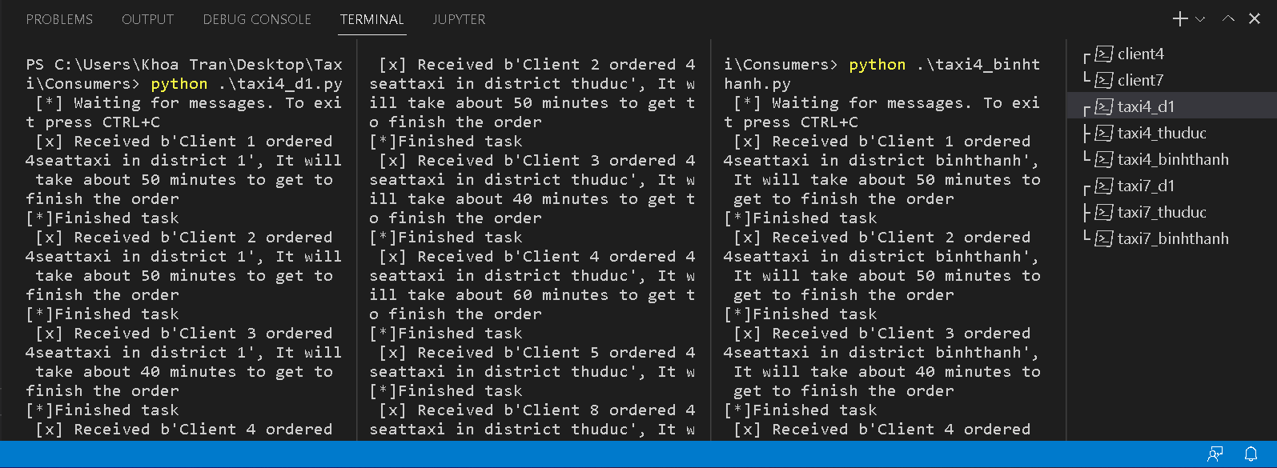

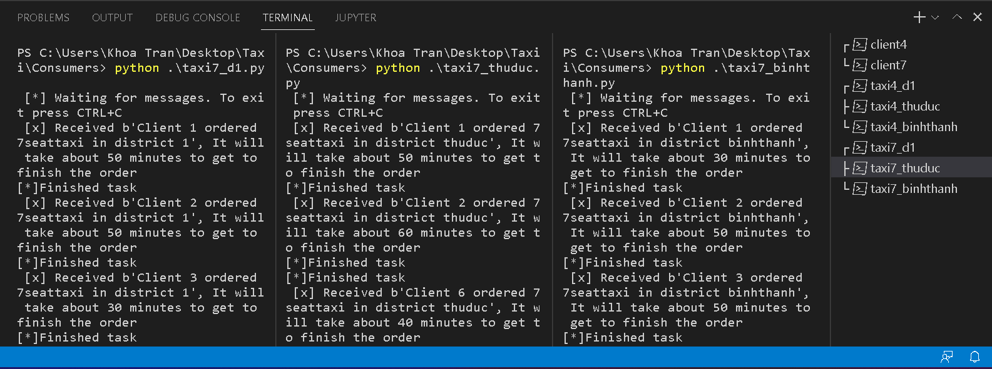

Now, at Queues on http://localhost:15672/, there are some queues have **Total = 0** and some have **Total = 1** with **Unacked = 1** (there’s still a message not be acked) and **Ready = 0** (After the message is acked, there will be no message in the queue).

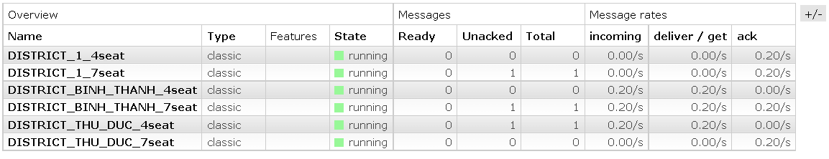

When all the consumers stop running. **Total** and **Ready** keep increasing the number of messages because those messages are not acked.

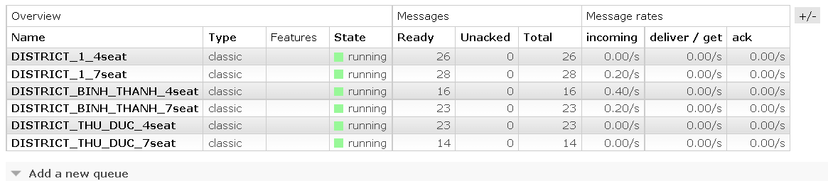

Then we move into queue **DISTRICT_BINH_THANH_4seat**

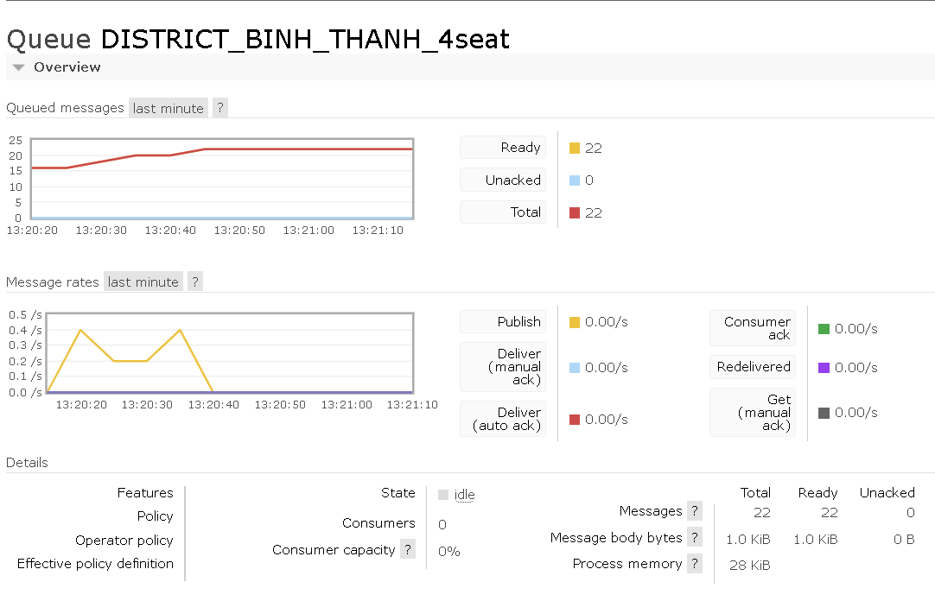

**Consumers = 0** so there is no place to receive the messages. 22 messages are now waiting in this queue.

This is a message is waiting inside the queue. It is delivered from **‘seatexchange’** bound with routing key name **‘4.binhthanh’**. Since this message was delivered successfully so there is no flag at **Redelivered**. At the **Payload**, we can see a line of message from the producer.

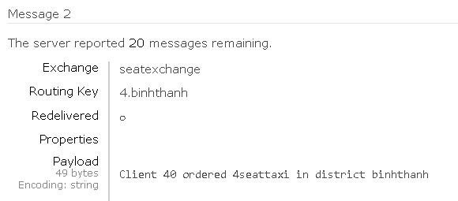

## Conclusion

RabbitMQ helps the web server to send responses to requests very quickly instead of being forced to run a resource-hungry procedure on a system. Storing messages in the queues is a great solution or we want to distribute the message to many recipients to help reduce the load on the workers to handle.

## Rerestriction

Networks are unreliable and applications may fail to process messages, therefore, the AMQP model has a notion of message acknowledgments: when a message is delivered to a consumer the consumer notifies the broker, either automatically or as soon as the application developer chooses to do so. When message acknowledgments are in use, a broker will only completely remove a message from a queue when it receives a notification for that message (or group of messages).

For example, when a message cannot be routed, messages may be returned to publishers, dropped, or, if the broker implements an extension, placed into a so-called "dead letter queue". Publishers choose how to handle situations like this by publishing messages using specific parameters.

## Development orientation

Because of our shortage of knowledge about programming in Python, we cannot add more suitable features for this project. In the future, we are going to upgrade the code which can help the taxi be able to send every kind of message back to the clients such as Confirming messages, Canceling messages, Late-notifying messages,... On the other hand, the taxi can send their real-time destination to the clients.

# REFERENCES

1. [RabbitMQ Tutorial - YouTube](https://www.youtube.com/playlist?list=PLalrWAGybpB-UHbRDhFsBgXJM1g6T4IvO)
2. [Microservices and Message Queues - Explained - YouTube](https://www.youtube.com/watch?v=r5byURobuaQ&list=PLJok6MNBwp_F-atjd6ylnzQK77Ag6YtLt&index=2)
3. [The New Method to Setup Raspberry Pi (2022 Update) - YouTube](https://www.youtube.com/watch?v=jRKgEXiMtns&t=424s)
4. [An introduction to RabbitMQ, a broker that deals in messages. | by Chandrabhan | We’ve moved to freeCodeCamp.org/news | Medium](https://medium.com/free-code-camp/rabbitmq-9e8f78194993)
5. [Lab-53: AMQP 1.0 protocol – Welcome to cloudNet (wordpress.com)](https://sunnynetwork.wordpress.com/2018/02/27/lab-53-amqp-protocol/)
6. [AMQP vs MQTT: Comparing Instant Messaging Protocols (cometchat.com)](https://www.cometchat.com/blog/amqp-vs-mqtt-comparing-instant-messaging-protocols#:~:text=MQTT%20is%20ideal%20for%20a,handle%20any%20type%20of%20scenario.)
7. [Free RabbitMQ training course (cloudamqp.com)](https://training.cloudamqp.com/course/5)